GOOGLE ANALYTICS 4 FLOOD IT! ASSIGNMENT | By Nathan David
Instructor Guide
Overview
LEARNING OBJECTIVES
- Practice navigating Google Analytics 4.
- Answer business questions using Google Analytics 4 data.
- Interpret mobile app analytics and provide performance insights.

RECOMMENDED STUDENT PREPARATION
- Read Chapter 11: “Mobile App Analytics.”

BACKGROUND
Mobile apps are an integral component of owned media. Mobile app marketing technology tools collect critical digital marketing data. Armed with mobile app analytics data, s drive better results for businesses.

For this assignment, have students explore the popular mobile app analytics tool Google Analytics 4 via a demo account. The demo account reports actual mobile app analytics data for the mobile app Flood It! (Android and iOS). Students should explore both the Google Analytics 4 demo account and the Flood It! mobile app to better understand how data flows from a mobile app into Google Analytics 4.

Evaluation
Grade student responses using the answer key on the following page.

GOOGLE ANALYTICS 4 FLOOD IT! ASSIGNMENT ANSWER KEY
1. How many new users (in thousands) did the Flood It! mobile app have in July 2022?
46K

2. How many new users were acquired through Paid Search in July 2022?
2.8K or 2,779

3. How many returning users (in thousands) did the Flood It! mobile app have in July 2022?
29K

4. How many post_score events occurred in July 2022?
133K or 133,456

5. In minutes and seconds, what was the average engagement time?
6 minutes and 13 seconds

6. Which event name had the highest count in July 2022?
screen_view

7. What was the total revenue in July 2022?
$21.10

8. What was the average revenue per paying user in July 2022?
$1.10

9. Flood It! uses first opens as a proxy for app installs. What was the first_open event count in July 2022?
44,357 or 44K

10. How many users visited the app from the United States in July 2022?
4,886 or 4.9K
Instruction
Set the due date for this assignment after students have read “Digital Marketing Analytics” Chapter 11. Have the students follow the instructions for this assignment available in the “Student Resources” section of this chapter in Edify. Below are the student instructions for your reference.

STUDENT INSTRUCTIONS FOR “GOOGLE ANALYTICS 4 FLOOD IT! ASSIGNMENT”
You have been hired as a digital marketing for Flood It!. Please get familiar with your employer by exploring their mobile app, Android and iOS.

Flood It! is a real puzzle game in which you have to flood the whole game board with one color in fewer than the allowed steps. Flood It! has Google Analytics 4 implemented. The mobile

app data is flowing to the Google Analytics 4 demo project. The data available is typical of what you might see for a gaming app with in-app purchases.

Step 1
Gain access to a Google Analytics 4 demo account for Flood It!. Instructions for accessing this demo account are available from Google. Make sure when you access the demo account you navigate to the Property ‘GA4 - Flood-It!’ (see images below).

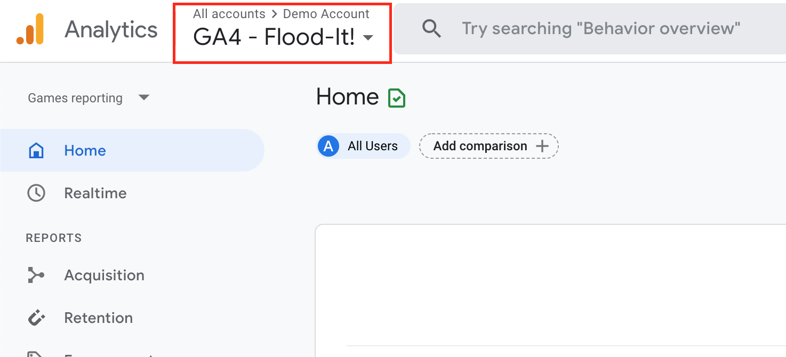

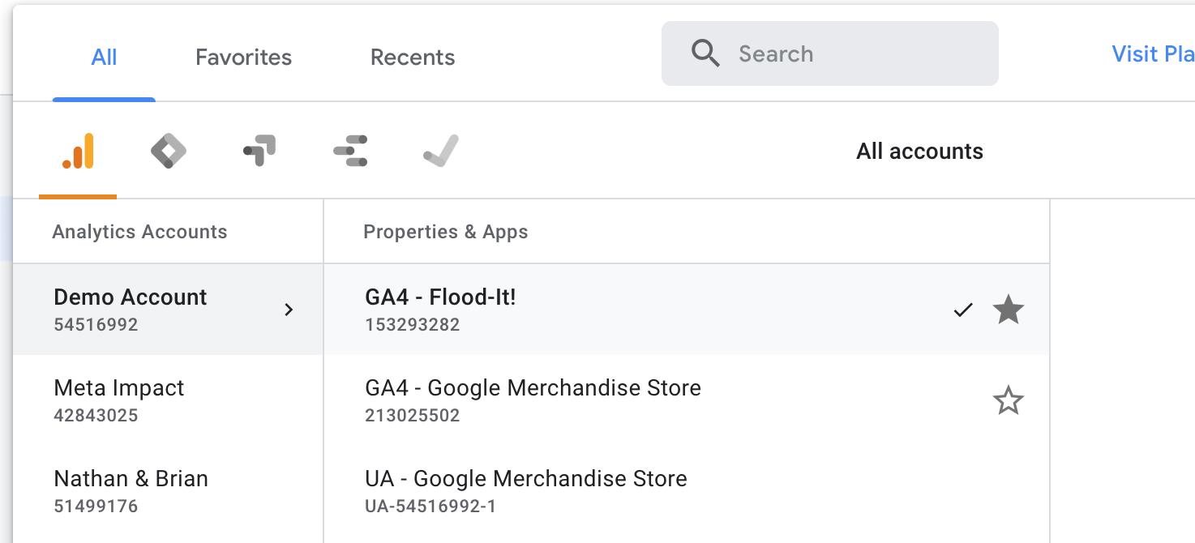

Step 2
Your manager is interested in the mobile app performance for Flood It! for the month of July 2022. When you open the Google Analytics 4 analytics dashboard, make sure you adjust the date filter in the upper right-hand corner to start on July 1, 2022, and end on July 31, 2022. Your manager has asked you to answer the following questions using data from the Google Analytics 4 demo account.

1. How many new users (in thousands) did the Flood It! mobile app have in July 2022?

2. How many new users were acquired through Paid Search in July 2022?

3. How many returning users (in thousands) did the Flood It! mobile app have in July 2022?

4. How many post_score events occurred in July 2022?

5. In minutes and seconds, what was the average engagement time?

6. Which event name had the highest count in July 2022?

7. What was the total revenue in July 2022?

8. What was the average revenue per paying user in July 2022?

9. Flood It! uses first opens as a proxy for app installs. What was the first_open event count in July 2022?

10. How many users visited the app from the United States in July 2022?

