[DEPARTMENT NAME]
[COLLEGE NAME]
COURSE PROPOSAL

Name:
Position:
Email:
Address:
Phone number:

I. Proposed course title
MKTG 000 – NAME, IMAGE & LIKENESS: Personal Branding Strategies for Student-athletes

II. Course description
The Name, Image & Likeness course will be designed to help student-athletes take advantage of their ability to monetize their name, image, and likeness. Students will learn the theory, strategy, and tactics of successful branding, with an emphasis on engaging an audience, generating followers, storytelling, and leveraging their position through successful pitch strategies.

III. Purpose of course
Learning Outcomes:
- Recognize opportunities in the new NIL guidelines for NCAA student-athletes.
- Describe the key metrics that can motivate NIL deals.
- Conduct a personal brand audit.
- Define a morality clause and explain how it impacts deals.
- Conduct a personal brand SWOT analysis of individual strengths, weaknesses, opportunities, and threats.
- Develop a personal brand statement.
- Develop buyer personas for the segments of the best followers and fans.
- Utilize strategies to gain more engagement and followers on social media.
- Define a brand hook.
- Write a personal brand elevator story.
- Develop a pitch to a business or individual.
- Create a media kit to present to businesses.
- Recognize the key elements to look for in a contract.
- Design a communications calendar for NIL social media efforts.
- Create a NIL one-page marketing plan.

IV. Elements of the Course
Quizzes: Every reading assignment from the textbook has an accompanying quiz. The reading of chapters and the quiz must be completed before class begins on the day the quiz is due.
Assignments: Every chapter has an accompanying assignment (except chapters one and ten). The assignment must be completed before class begins on the day the assignment is listed as due.
In-class Participation: You are expected to actively engage in classroom discussions. Both attendance and in-class engagement are components of your participation grade:
● Attendance: 5%
● In-class engagement: 5%

Final Exam: There will be one final exam. The exam will cover material from the textbook and the material covered in class.

V. Outline of course content:

Course Schedule for 1 Credit Class
Week | Topic | Reading | Assignments/Project/Quizzes/Exam | Mimic Name, Image & Likeness Simulation
1 | Build Your Brand for NIL Opportunities  Evaluate Your Brand | Chapter 1  Chapter 2 | • Activate Stukent Account  • In-class Discussion/Activities  • 1.1  • Chapter 1 Quiz  • Design Your Brand Audit  • In-class Discussion/Activities  • 2.1  • Chapter 2 Quiz | Introduction  Round 1
2 | Define Your Brand | Chapter 3 | • Create Your SWOT Analysis  • Set SMART Brand Goals  • Create Your Brand Statement  • In-class Discussion/Activities  • 3.1  • Chapter 3 Quiz | Round 2
3 | Your Entrepreneurial Opportunity | Chapter 4 | • Design Your NIL Opportunity  Map  • In-class Discussion/Activities  • 4.1  • Chapter 4 Quiz | Round 3
4 | Your Target Audiences | Chapter 5 | • Create Buyer Personas  • Create Your Audience Builder  • In-class Discussion/Activities  • 5.1  • Chapter 5 Quiz | Round 4
5 | Your Brand Differentiation | Chapter 6 | • Create Your Brand Differentiation  • Design Your Own Merchandise  • In-class Discussion/Activities  • 6.1  • Chapter 6 Quiz | Round 5
6 | Making Your Pitch | Chapter 7 | • Create Your Personal Brand Story  • Generate Your NIL Pitch  • In-class Discussion/Activities  • 7.1  • Chapter 7 Quiz | Round 6
7 | Brand Presentation | Chapter 8 | • Design a Media Kit  • In-class Discussion/Activities  • 8.1  • Chapter 8 Quiz | Round 7
8 | Your Marketing Plan  Your Brand Beyond College | Chapter 9  Chapter 10 | • Design a Communications  Schedule  • Develop a One-page NIL  Marketing Plan  • In-class Discussion/Activities  • 9.1  • Chapter 9 Quiz  • In-Class Discussion/Activities  • 10.1  • Chapter 10 Quiz | Round 8

Course Schedule for 3 Credit Class
Week | Topic | Reading | Assignments/Project/Quizzes/Exam | Mimic Name, Image & Likeness Simulation
1 | Build Your Brand for NIL Opportunities | Chapter 1 | • Activate Stukent Account  • In-class Discussion/Activities  • 1.1  • 1.2  • Chapter 1 Quiz
2 | Evaluate Your Brand | Chapter 2 | • Design Your Brand Audit  • In-class Discussion/Activities  • 2.1  • 2.2  • Chapter 2 Quiz
3 | Define Your Brand – Part I | Chapter 3 | • Create Your SWOT Analysis  • In-class Discussion/Activities  • 3.1  • Chapter 3 Quiz
4 | Define Your Brand – Part II | Chapter 3 | • Set SMART Brand Goals  • Create Your Brand Statement  • In-class Discussion/Activities  • 3.2
5 | Your Entrepreneurial Opportunity | Chapter 4 | • Design Your NIL Opportunity  Map  • In-class Discussion/Activities  • 4.1  • 4.2  • Chapter 4 Quiz
6 | Your Target Audiences –  Part I | Chapter 5 | • Create Buyer Personas  • In-class Discussion/Activities  • 5.1 | Introduction
7 | Your Target Audiences –  Part II | Chapter 5 | • Create Your Audience Builder  • In-class Discussion/Activities  • 5.2  • Chapter 5 Quiz | Round 1
8 | Your Brand Differentiation – Part I | Chapter 6 | • Create Your Brand Differentiation  Formula  • In-class Discussion/Activities  • 6.1 | Round 2
9 | Your Brand Differentiation – Part II | Chapter 6 | • Design Your Own Merchandise  • In-class Discussion/Activities  • 6.2  • Chapter 6 Quiz | Round 3
10 | Making Your Pitch – Part I | Chapter 7 | • Create Your Personal Brand Story  & Elevator Statement  • In-class Discussion/Activities  • 7.1 | Round 4
11 | Making Your Pitch – Part II | Chapter 7 | • Generate Your NIL Pitch  • In-class Discussion/Activities  • 7.2  • Chapter 7 Quiz | Round 5
12 | Brand Presentation | Chapter 8 | • Design a Media Kit  • In-class Discussion/Activities  • 8.1  • 8.2  • Chapter 8 Quiz | Round 6
13 | Your Marketing Plan – Part I | Chapter 9 | • Design a Communications  Schedule  • In-class Discussion/Activities  • 9.1 | Round 7
14 | Your Marketing Plan – Part II | Chapter 9 | • Develop a One-page NIL  Marketing Plan  • In-class Discussion/Activities  • 9.2  • Chapter 9 Quiz | Round 8
15 | Your Brand Beyond College | Chapter 10 | • In-class Discussion/Activities  • 10.1  • 10.2  • Chapter 10 Quiz

VI. Proposed courseware
This course uses a digital textbook, accessed at http://home.stukent.com.
Name, Image & Likeness
Publisher: Stukent, Inc.
Author: Dr. Maribeth Kuzmeski
ISBN: 978195963151
Direct From Stukent Price: $79.99
https://www.stukent.com/higher-ed/name-image-likeness/
Name, Image & Likeness/Mimic NIL Bundle
Publisher: Stukent, Inc.
ISBN: 978-1-7374823-6-9
Author: Dr. Maribeth Kuzmeski
Direct From Stukent Price: $119.99
https://www.stukent.com/higher-ed/mimic-nil/

Chapter 1: Build Your Brand for NIL Opportunities
Chapter 2: Evaluate Your Brand
Chapter 3: Define Your Brand
Chapter 4: Your Entrepreneurial Opportunity
Chapter 5: Your Target Audiences
Chapter 6: Your Brand Differentiation
Chapter 7: Making Your Pitch
Chapter 8: Brand Presentation
Chapter 9: Your Marketing Plan
Chapter 10: Your Brand Beyond College

This courseware accomplishes the following objectives:
- Provides easily-accessible material
- Ensures up-to-date NIL content
- Limits student costs
- Enhances training in NIL strategies
To take advantage of NIL opportunities, student-athletes need to focus on building strong, positive, and engaging personal brands. Student-athletes can command attention from businesses, organizations, and individuals by flexing their name, image, and likeness.
This course presents marketing strategies, best practices, and pitches to capitalize on NIL opportunities as a student-athlete and beyond.

VII. Sample Assignment(s)
NIL Pitch Assignment
OVERVIEW
As a student-athlete, your goal is to “hook” potential deals and contracts with compelling bait. But to hook potential deals, you must understand what interests your audiences. Moreover, your presentation of what could be interesting is critical. In order to develop your hook, you have to design the right messaging about you and what you can bring to the table.
A pitch is a presentation where the opportunity and benefits are shared with a business or individual, usually in a few sentences, followed by additional information.
INSTRUCTIONS
Download the NIL Pitch Formula to draft your pitch. Here is a sample of how to build your pitch.
YOUR STORY AND PROVE IT: I’m a three-point-shooting basketball player at Minnesota State and have an engaged following of more than 30,000 on Instagram.
WHAT’S IN IT FOR THEM: I eat your “Famous Protein Bars” during the halftime of every game. I would like to talk to you about how I could promote your brand and generate more sales for you!
EMAIL SUBJECT LINE: College Athlete Believes “Famous Protein Bars” Help With Performance
PITCH RESULT: I’m a three-point shooting basketball player at Minnesota State and have an engaged following of more than 30,000 on Instagram. I eat your “Famous Protein Bars” during the halftime of every game. I would like to talk to you about how I could promote your brand and generate more sales for you!
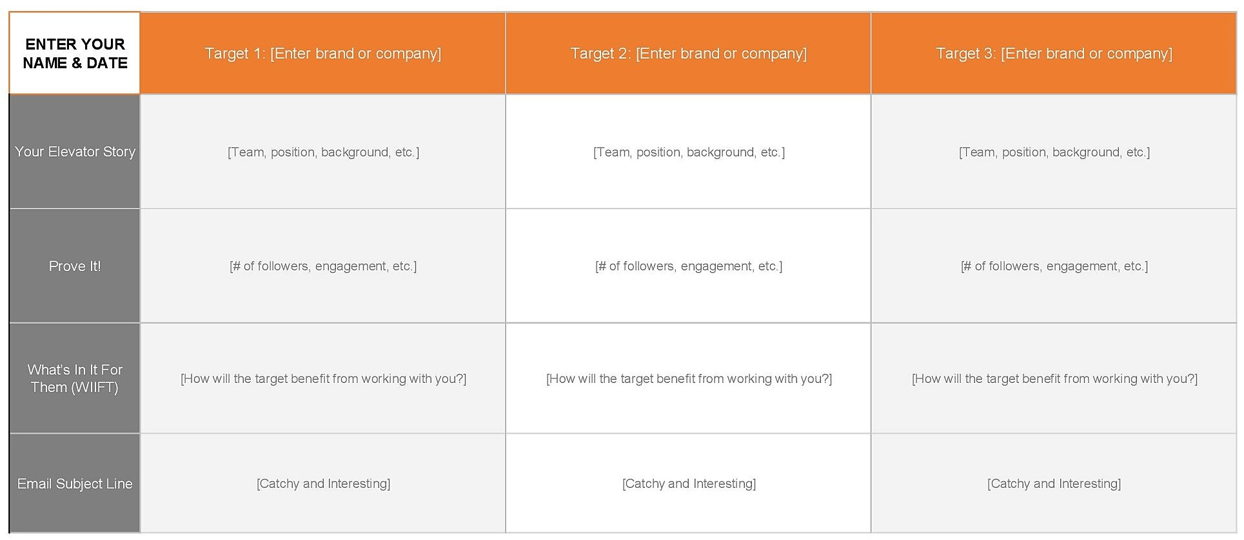

VIII. Grading
The assessment and grading system is intended to reflect student learning and performance.

Assignments 50%

Simulation 10%

Quizzes 20%

Exam 20%

